|  |
| --- |
| **Procurement policy template** |

|  |
| --- |
| User notes Procurement has three stages: planning, sourcing, and managing. This policy template applies the New Zealand Government’s *Principles of Government Procurement* and the *Government Procurement Rules* to these 3 stages*.* You can customise it to your agency’s needs by typing over the highlighted areas and adapting the content.  Developing and launching a new procurement policy for your agency is a chance to get people thinking about good procurement practices. It can also lead to discussion about achieving better value for money by taking a strategic approach to managing your agency’s spend.  Before you start customising the policy, it may help to discuss with your executive team:   * how procurement supports your agency’s purpose * how procurement supports your agency to deliver its strategic priorities * how this is reflected in the policy * how good procurement practices can benefit your agency * who your agency’s buyers are, what they need to know, and how this information is covered in your policy or procedures * how you intend to support procurement activity across your agency.   how you will commit to good practices throughout the procurement lifecycle – including on an ongoing basis as the contract is managed.  Procurement is often an agency-wide activity, so consider asking your chief executive officer (CEO) to write a foreword for your policy that highlights key messages.  It’s good practice to make your procurement policy publicly available.  Policies should be reviewed and updated regularly. You should also update based on major changes, like shifting needs or new roles at your agency, or new government priorities / legislation.  You can also consider your plan for emergency procurement. This may already be covered in your agency’s risk management strategy, but you can reference it in this procurement policy document to ensure awareness and compliance within your organisation.  Although elements of your policy will be specific to your agency, many public sector agencies have similar patterns of procurement, for example, for office supplies, ICT equipment, or specialist consultancy services. Your agency could compare policy notes with other agencies for shared learning.  This template does not include detailed procurement procedures. The scale, complexity and risks involved in procurement vary widely between agencies – so there’s no overall approach for everyone. If your procedures need to be updated for consistency with the *Government Procurement Rules*, you can email [procurement@mbie.govt.nz](mailto:procurement@mbie.govt.nz) for assistance*.* |

|  |
| --- |
| [insert agency logo] |

[Name of agency]

Procurement policy

|  |  |
| --- | --- |
| Document development control | |
| Prepared by: |  |
| Position / title: |  |
| Document version: | 1.0 |
| Date of last revision: |  |
| Status: | [Choose: draft / final for peer review / final for approvals / final as approved] |

**Our procurement**

[This section explains what procurement is and why it’s important to do it well. To customise this section, describe how procurement contributes to your agency’s purpose and/or government priorities. If your CEO has written a foreword, include it here.]

Effective procurement helps us deliver more projects on time and within budget. It means less cost of doing business for all involved, and reduces our exposure to commercial risk. Effective procurement can improve productivity and support supplier innovation.

This policy provides a structure for how [agency name] procures goods and services and manages ongoing contracts. It reflects government guidance and the standards required by law, and follows the procurement life cycle.

Procurement covers all the processes around buying the goods/services/works we use to run our organisation and deliver our public service objectives. It starts with applying any lessons learned from the review of past procurements. We identify our needs, then plan the best way to meet them. Then, we source the goods/services/works and manage the resulting contract. Contracts may be renewed, then the contract may expire or the asset will reach the end of its useful life. At this point we review the whole procurement for more lessons learned, then start the cycle again.

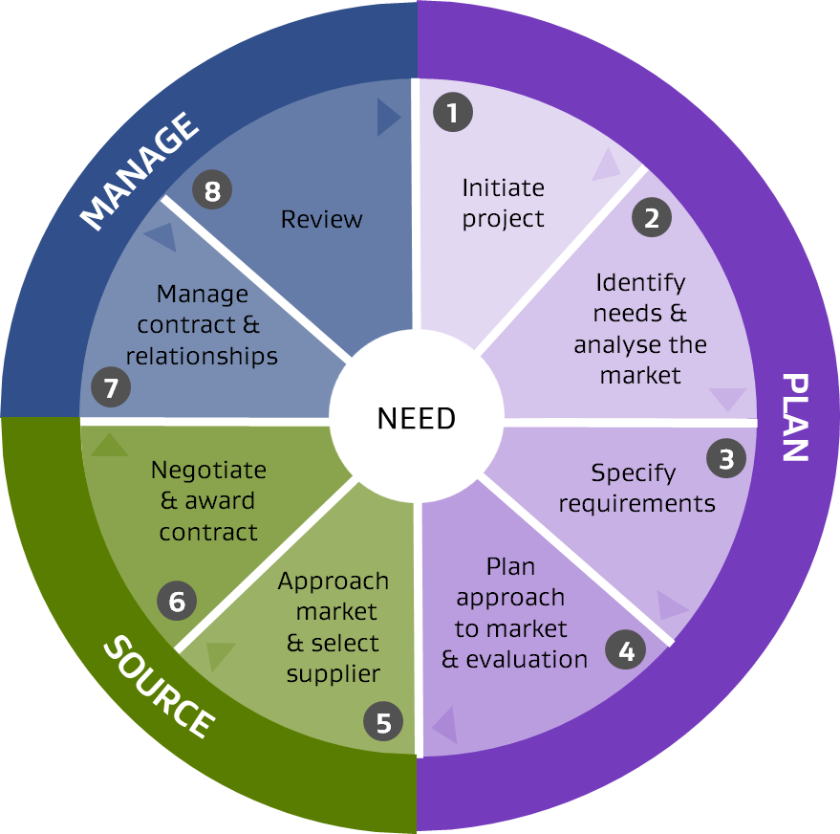

Our agency has a mandate to [describe your agency’s purpose or key strategic objectives as outlined in its Statement of Intent and how procurement supports this. You may like to refer to your agency’s values.]

**Purpose and scope**

This policy and [agency’s] procurement proceduresoutline the approach that [agency name] will take to planning, sourcing and managing our procurement. They must be followed by all our temporary and permanent employees, consultants and contractors. Any departure from this approach must first be approved by [add title(s)].

This policy does not apply to the procurement of employees on fixed-term and permanent employment contracts. For assistance with these, please contact [team/position title].

[If your agency routinely does other non-procurement activities that will not be covered by the policy, for example, unconditional grants – you can add them here.]

**Accountability**

[This section can define your review cycle; which teams or individuals ultimately own the policy; who is responsible for compliance with the policy; and who is responsible for implementing the policy at a high level. More specific responsibilities can be defined in the ‘Roles and responsibilities’ section later in this document.]

We will review this policy every [3] years, or as required by staffing and legislation changes.

**Our procurement objectives**

[The *Government* *Procurement* *Rules* require agencies to maximise public value, including value for money. The rules also require agencies to consider [broader outcomes](https://www.procurement.govt.nz/procurement/principles-charter-and-rules/government-procurement-rules/planning-your-procurement/broader-outcomes/) – secondary benefits generated from procurement activity. Not every outcome can be incorporated into every procurement, but you can specify how you will consider broader outcomes within your policy. You can add other key objectives to reflect your agency’s purpose and priorities. The text below is an example.]

**Broader outcomes**

New Zealand Government Procurement Rules require us to consider the following priority outcomes within our procurement activity:

* Increasing access for New Zealand businesses
* Construction skills and training
* Improving conditions for New Zealand workers; and
* Reducing emissions and waste.

The actions listed under ‘How we work’ include steps to deliver broader outcomes where possible.

**Our procurement objectives**

* Get the best results from our spending, including sustainable value for money over the lifetime of the goods/services/works we buy.
* Raise performance standards through fair and effective management of our suppliers and service providers, to get the best public services for New Zealand.
* Help New Zealand businesses to grow capability and increase international competitiveness. We’ll achieve this by working with them to identify opportunities to innovate and continuously improve planning, decision making and ongoing contract management.

**How we work**

We will apply the Principles of Government Procurement and Government Procurement Rules when planning, sourcing and managing our procurement, as these set the standard for good practice (including financial thresholds and procedures for advertising procurement opportunities).

The way we buy goods/services/works will vary depending on the value, complexity and risk involved. We will apply the approach best suited to the individual purchase, within the framework of the Principles and Rules – encouraging competitive tendering whenever possible.

*Principles of Government Procurement* and *Government Procurement Rules*

The principles are:

1. Plan and manage for great results
2. Be fair to all suppliers
3. Get the right supplier
4. Get the best deal for everyone
5. Play by the rules

The rules are available at [​​Government Procurement Rules | New Zealand Government Procurement](https://www.procurement.govt.nz/procurement/principles-charter-and-rules/government-procurement-rules/).

#### Before we start

The person or team requesting the procurement needs to provide a detailed scope of work with defined requirements. It should describe the required outcomes, rather than specifying any particular solutions. If a solution is defined too early, we could miss out on better, more innovative options. The detailed scope of work will be used for writing procurement RFx documents.

#### Planning

When planning procurement projects, we will:

* use processes proportionate to the size, complexity and risks involved in the contract
* make sure we have up-to-date knowledge about the market and the effect our procurement has on it
* publish future procurement opportunities and/or advance notices, to help increase access for New Zealand businesses
* involve suppliers early in the process, fairly and transparently, to explain our needs, learn about them and explore opportunities for new solutions before going to market. This helps us save costs to suppliers, if it turns out they are not well placed to bid, and can reduce risk of later complaints
* consider subcontracting opportunities in big projects, so small and medium enterprises can grow their business capability
* include requirements for industry training, fair working conditions, and lower emissions in our specifications where appropriate
* write tender documents clearly, without unnecessary questions or jargon, to make it easier for New Zealand businesses to bid for our opportunities
* ensure we have financial approval aligned with [agency name’s] financial delegations policy (at least in principle) before going to market.

#### Sourcing

When we buy goods/services/works, we will:

* purchase from government collaborative contracts, or [agency name’s] existing supply contracts if they can meet our requirements
* give all suppliers a full and fair opportunity to compete – we will not discriminate on the basis of where suppliers come from or whether they have prior experience of working with government
* be open to involving New Zealand businesses as sub-contractors
* choose suppliers that have demonstrated their ability to meet our requirements and offer the best value-for-money over the lifetime of the goods/services/works, taking into account:
  + all the costs of ownership over that lifetime
  + suppliers’ ability to deliver what we need at a fair price and on time
  + the social, environmental and economic effects of the deal, including the suppliers’ approach to health and safety and reducing emissions and waste
* use approved government model templates as our default tender and contract documents
* have an approved purchase order/agreement in place before the supplier starts delivering goods/services/works – except when using a purchasing card.

For details on existing supplier arrangements at [agency name], contact [team/position title].

#### Managing the contract

To get the best from our suppliers, we will:

* set clear performance measures, including for working conditions, and reducing emissions and waste; then monitor and manage the contract against them
* encourage and recognise suppliers for delivering great results
* actively work with suppliers to make ongoing savings and improvements for both entities. This will help to avoid ‘value erosion’ and encourage suppliers to maintain innovation at the same pace over the life of the contract.

#### Meeting expectations

To build effective relationships with suppliers, we will:

* treat them all fairly and with respect
* be consistent, transparent, fair and accountable in the way we work
* be clear about what we require and how we will assess them before going to market
* give sufficient response time for our requests
* protect their commercially sensitive information and intellectual property
* offer a debrief to unsuccessful bidders
* pay invoices promptly.

#### Playing by the rules

Our decisions and practices must be able to withstand public scrutiny at all times. Demonstrating high standards of probity is essential to public confidence in our public services. Throughout our procurement activities, we will:

* clearly record our planning, processes and decisions so they can easily be audited
* document and manage conflicts of interest, including perceived conflicts of interest
* identify risks and get the right person to manage them
* act lawfully, ethically and responsibly.

Thresholds

[For goods, services and refurbishment works, the Government Procurement Rules require procurements over $100,000 to go to open tender. For construction works, the threshold is $9 million. Other thresholds will depend on your agency’s own financial delegations policy. Specific steps for procurements at these thresholds, like when to engage your procurement team and which documents to use, should be detailed in your agency’s procedures].

Our standard procurement processes are detailed in [agency name’s procurement procedures and/or intranet] and are based on monetary thresholds.

**Goods, services and refurbishment works**

* [Under $x – buy directly from a suitable supplier].
* [$x to $100,000 – three quotes or closed tender].
* Over $100,000 – open tendering, using the Government Electronic Tender Service (GETS).

**New construction works**

[The *Government Procurement Rules* require open tendering for construction worth $9 million or more, but you can set a lower threshold for your agency.]

* [$x to $x – three quotes or closed tender].
* Over [$9 million] – open tendering, using the Government Electronic Tender Service (GETS).

**Emergencies**

[Your agency should have a plan to manage the risk of major events like a pandemic or natural disaster, and this plan should allow for the provision of goods and services during an emergency or supply shortage. Good risk management will reduce the need for emergency procurement.

You can’t plan for everything you may need to procure in an emergency, but your policy can list the best practice actions you will still take, including documentation. For guidance on what to do at different levels of emergency, read the Guide to emergency procurement.

[Guide to emergency procurement](https://www.procurement.govt.nz/procurement/specialised-procurement/emergency-procurement/)

[Agency name] recognises that in an emergency, we may need to depart from usual procurement processes in order to respond effectively. We will still follow best practices for emergency situations including:

* documenting our emergency procurements during the event, or as soon as possible afterwards
* acting within existing delegated authority, where possible
* if there is no existing delegated authority, and no time to obtain an approval, exercising good judgement and being prepared to provide a rationale for procurements
* if a procurement involves a major expense, obtaining verbal approval, at the very least, from an officer with sufficient delegated financial authority – followed up in writing – before making a commitment.

**Roles and responsibilities**

[Roles and responsibilities for procurement activities vary between agencies and may be summarised in your policy or procurement procedures. The following is an example.]

[Agency name’s] managers are responsible for:

* managing their business unit’s purchasing requirements up to $100,000
* ensuring their staff apply [agency name’s] procurement policy and procedures.

Our [commercial services/procurement team] is responsible for all purchases over [$100,000] and can assist with lower value purchases on request.

Our legal team is responsible for drafting and approving contracts over [$x].

All staff are responsible for applying our procurement policy and procedures.

**Related procurement documents and law**

Procedures, policies and guidance

[This example is not an exhaustive list. You can expand it to meet your agency’s needs.]

* [Agency name’s] procurement policies and procedures. [This may include any flow charts or diagrams of your agency’s procurement process.]
* [Agency’s finance and/or tax policy]
* [Agency’s delegated financial authority policy].
* [Agency’s purchasing / credit card policy].
* [Agency’s code of conduct].
* [Agency’s health and safety policy]
* [Agency’s gifts and hospitality policy].
* [*Government Procurement Rules.*](https://www.procurement.govt.nz/procurement/principles-charter-and-rules/government-procurement-rules/)
* [*Principles of Government Procurement.*](https://www.procurement.govt.nz/procurement/principles-charter-and-rules/government-procurement-principles/)

Legislation

* Public Finance Act 1989.
* Commerce Act 1986.
* Public Records Act 2005
* [Relevant sector specific legislation, for example, Crown Entities Act 2004].

**Policy owner**

This policy is the responsibility of [position title].

**Further information**

For more information on [agency name’s] procurement, please contact [position title or team name] on [phone number or email].